**SQL Portfolio Assignment:**

**Question No: 01**

How many customers has Foodie-Fi ever had?

**Query:**

Select count(distinct customer_id) as Customers from subscriptions;

**Output:**

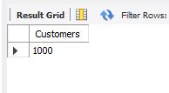

**Question No: 02**

What is the monthly distribution of trial plan start date values for our dataset - use the start of the month as the group by value.

**Query:**

select plan_id,month(start_date) as month,count(month(start_date)) as count from subscriptions

group by month(start_date),plan_id

having plan_id=0;

**OUTPUT:**

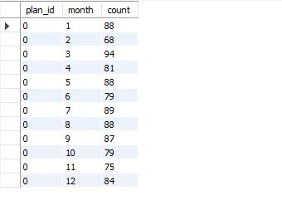

**Question No: 03**

What plan start date values occur after the year 2020 for our dataset? Show the breakdown by count of events for each plan name

**Query:**

select plans.plan_name,sp.plan_id ,year(start_date) as year,count(year(start_date)) as Count_of_events from subscriptions as sp

join plans on sp.plan_id=plans.plan_id

where year(start_date)>2020

group by plans.plan_name,plan_id,year(start_date);

**OUTPUT:**

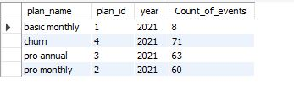

**Question No: 04**

What is the customer count and percentage of customers who have churned rounded to 1 decimal place?

**Query:**

select plan_name,

count((select count(distinct customer_id) from subscriptions)) as count_of_churned,

ROUND(count(plans.plan_name)/(select count(distinct customer_id) from subscriptions),1)*100 as Percentage

from subscriptions as sp

join plans on sp.plan_id=plans.plan_id

where plan_name='churn';

**OUTPUT:**

**Question No: 05**

How many customers have churned straight after their initial free trial - what percentage is this rounded to the nearest whole number?

**Query:**

select plan_id,count(customer_id) as count_customer,

Round(count(customer_id)/(select count(customer_id) from subscriptions),3)*100 as Percentage

from subscriptions where plan_id=4

and customer_id in(select customer_id from subscriptions where plan_id=0);

**OUTPUT:**

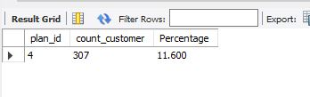

**Question No: 06**

What is the number and percentage of customer plans after their initial free trial?

**Query:**

SELECT COUNT(plan_id) AS count_cust,

ROUND(count(customer_id)/(select count(customer_id) from subscriptions),2)*100 as Percentage

FROM subscriptions

WHERE plan_id != 0;

**OUTPUT:**

**Question No: 07**

What is the customer count and percentage breakdown of all 5 plan name values at 2020-12-31?

**Query:**

select plan_name,count(customer_id) as count,

ROUND(count(plan_name)/(select count(customer_id) from subscriptions),5)*100 as Percentage

from subscriptions as sp

join plans as p on sp.plan_id=p.plan_id

where start_date='2020-12-31'

group by plan_name;

**OUTPUT:**

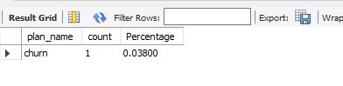

**Question No: 08**

How many customers have upgraded to an annual plan in 2020?

**Query:**

select plan_name,count(customer_id) as count

from subscriptions as sp

join plans as p on sp.plan_id=p.plan_id

where plan_name='pro annual' AND year(start_date)='2020';

**OUTPUT:**

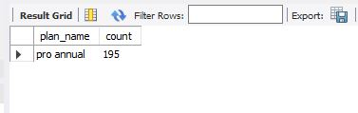

**Question No: 09**

How many days on average does it take for a customer to make an annual plan from the day they join Foodie-Fi?

**Query:**

Select count(customer_id) as No_of_customers,AVG(DATEDIFF(

(Select Min(start_date) from subscriptions as s1 where s1.customer_id=s2.customer_id and plan_id=3),

(Select MIN(start_date) from subscriptions as s3 where s3.customer_id=s2.customer_id )

))

as AVG_Days_to_reach_annual_program

from subscriptions as s2

where plan_id !=3;

**OUTPUT:**

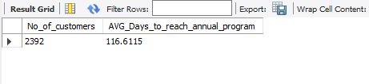

**Question No: 10**

Can you further breakdown this average value into 30-day periods (i.e. 0-30 days, 31-60 days etc)

**Query:**

SELECT

CASE

WHEN days_difference >= 0 AND days_difference <= 30 THEN '0-30 days'

WHEN days_difference > 30 AND days_difference <= 60 THEN '31-60 days'

WHEN days_difference > 61 AND days_difference <= 90 THEN '61-90 days'

ELSE 'More than 90 days'

END AS period,

COUNT(customer_id) AS No_of_customers,

AVG(days_difference) AS AVG_Days_to_reach_annual_program

FROM (

SELECT

s2.customer_id,

DATEDIFF(

(SELECT MIN(start_date) FROM subscriptions AS s1 WHERE s1.customer_id = s2.customer_id AND plan_id = 3),

(SELECT MIN(start_date) FROM subscriptions AS s3 WHERE s3.customer_id = s2.customer_id)) AS days_difference

FROM subscriptions AS s2 WHERE plan_id != 3 AND plan_id != 4) AS differences

GROUP BY period

ORDER BY period;

**OUTPUT:**

**Question No: 11**

How many customers downgraded from a pro monthly to a basic monthly plan in 2020?

**Query:**

select plan_id,count(distinct customer_id)as downgraded_from_annual_to_basic from subscriptions

where plan_id =1

and customer_id in

(select distinct customer_id from subscriptions where plan_id=2 and year(start_date)=2020);

**OUTPUT:**

**GitHub:** [**https://github.com/Hammad112/Foodie-Fi**](https://github.com/Hammad112/Foodie-Fi)

**Medium:** **https://medium.com/@hammadnasir797/sql-case-study-foodie-fi-3a2c579549d9**